Background information

In this task participants are presented with a set of words, each displayed in a colored ink. The task is to say the color in which the word is printed. There are 2 conditions:

1. Congruent words condition - words displayed are colors that do match the color in which they are printed
2. Incongruent words condition -– words displayed are colors that do not match the color in which they are printed

In both cases we measure the time taken to name ink colors in equally-sized lists. Each participant will have time recorded for both conditions.

Questions for investigation

1. What is our independent variable? What is our dependent variable?
   * Dependent variable -– time to name the ink colors
   * Independent variable -– condition (congruent vs incongruent)
2. What is an appropriate set of hypotheses for this task? What kind of statistical test do you expect to perform?

For hypothesis testing:

* H0 The means of the two populations formed by the congruent & incongruent conditions are the same.
* Ha The means of the two populations are different

If we write this in symbols it would look like:

H0: μc = μi

Ha: μc != μi

We can say that the data is roughly normally distributed with a slight left tail. First of all, t-test can be a suitable test because of the unknown population variance. Usage of the two-tailed dependent t-test can be justified by the comparison of 2 dependent samples of data.

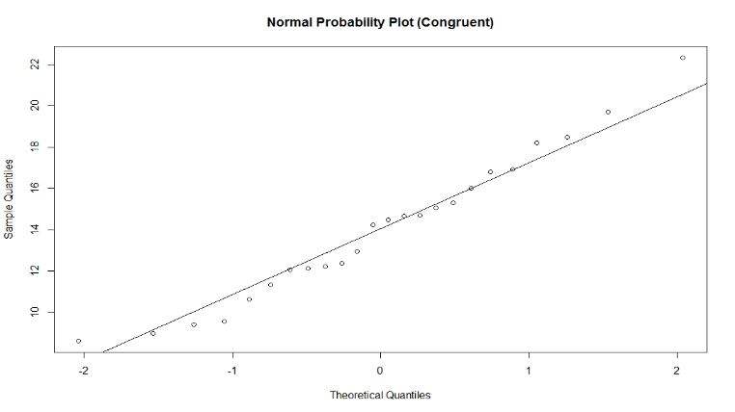

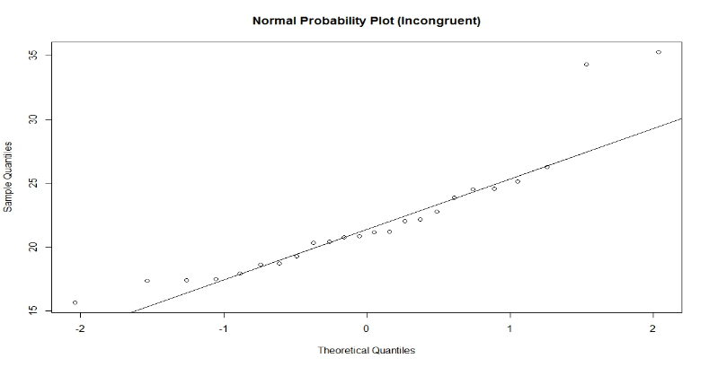

1. Report some descriptive statistics regarding this dataset.

Congruent Incongruent

Median :14.36 Median :21.02

Mean :14.05 Mean :22.02

SD :3.56 SD :4.80

1. Provide one or two visualizations that show the distribution of the sample data. Write one or two sentences noting what you observe about the plot or plots.

Congruent tasks appear to be completed significantly faster compared to incongruent.

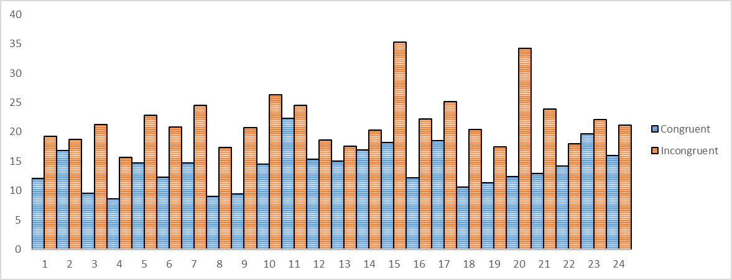

1. What is your confidence level and your critical statistic value? Do you reject the null hypothesis or fail to reject it? Come to a conclusion in terms of the experiment task. Did the results match up with your expectations?

Null hypothesis should be rejected. At α 0.05, the time to name colors is SIGNIFICANTLY different between the tasks (congruent vs incongruent). People are unable to name colors at the same speed when the meaning of the word & its color match, opposed to when they don’t. The results are in line with my expectations.

t = -8.0207, df = 23, P = 4.103E-08

mean of the differences -7.9648

at α 0.05, t-critical: -2.06865761; 2.06865761

95% CI: (-10.019, -5.910)

1. Optional: What do you think is responsible for the effects observed? Can you think of an alternative or similar task that would result in a similar effect?

The human brain easily associates between the meaning of the word & it’s color. When a mismatch occurs additional processing time is necessary to comprehend the information & decide on its meaning.

In my opinion the visual color representation would be more ingrained compared to the shape association.